OUT OF SCOPE IF:
- Rent other than land or gas/oil lease
- There are any expenses associated with this income
- Rent is for residential property (room in home, apartment, over garage, separate building, for profit, not for profit, Airbnb, etc,)
  - Rental of your main home for less than 15 days during the year is not a taxable event. See NTTC Modified 4012-page D-50 for more information.
- Income relates to a Qualified Joint Venture
- Income is from a state (other than NJ) which requires a state return to be filed if there is income from that state (e.g. NY, CA)
Rent Income
- Rent income is in-scope if
  - Land OR gas/oil lease and
  - Reported on a Form 1099-MISC or
  - Received from individual and not reported on 1099-MISC
- No Expenses EXCEPT property tax
  - Report on Schedule A
- Rent reported on a K-1 – OUT OF SCOPE
- TSO Entry
  - Select 1099-MISC by entering form number in search box OR clicking through Federal Income
  - Complete 1099-Misc with amount in box 1
  - TaxSlayer will prompt Schedule E when 1099-MISC is completed

  - If no 1099-MISC add Sch E by entering form number in the search box or clicking through Federal Income.
  - Schedule E Required Information – Check here box should not be checked. OUT OF SCOPE if TP filed form 1099s.

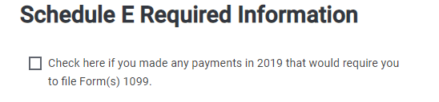

Complete The Schedule

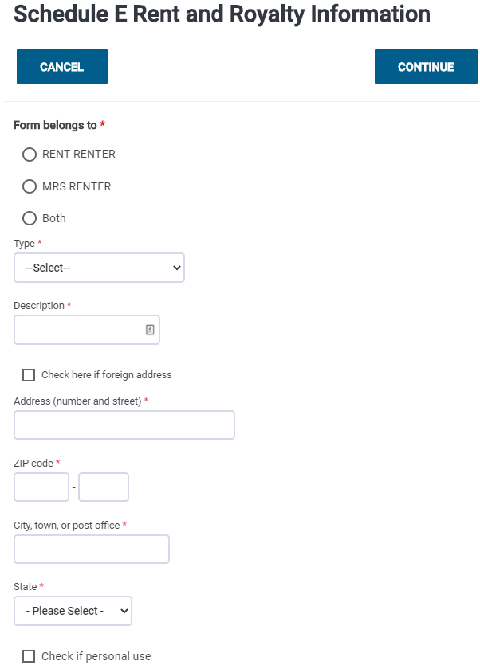
Select “Land” from the drop box.

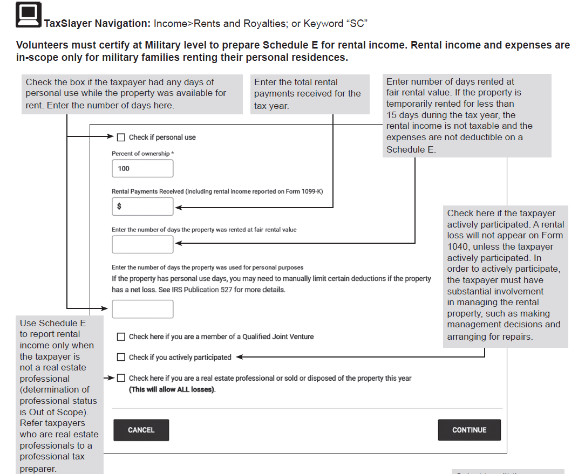

Enter rent not on 1099 MISC

  - Depreciation, expenses and Car and Truck Expenses are OUT OF SCOPE

Royalty Income
- Royalties from a gas/oil lease or similar are In-Scope if reported on K-1 or 1099-MISC (Sch E)
- Royalty from own personal services is business income on Sch C (such as author’s or entertainer’s royalty). Enter Royalty amount in box 7 in order to get it to Sch C.
- Royalties reported on a K-1 are entered directly into the TSO K-1
- TSO Entry Royalties reported on a 1099-MISC
  - Select 1099-MISC by entering form number in search box clicking through Federal Income
  - Complete 1099-Misc with amount in box 2 if royalty from gas/oil lease or similar
  - TaxSlayer will prompt Schedule E when 1099-MISC is completed

  - If no 1099-MISC add Sch E by entering form number in the search box OR clicking through Federal Income
  - Schedule E Required Information – Check here box should not be checked. OUT of Scope if TP filed form 1099s

Complete Schedule E as described above.
    - Type from dropdown = Royalties
    - Royalty amount will be transferred from the 1099-MISC
    - Enter Royalty directly if no 1099-MISC

Rents and Royalties entered on Sch E will transfer to 1040 Schedule 1 line 5

